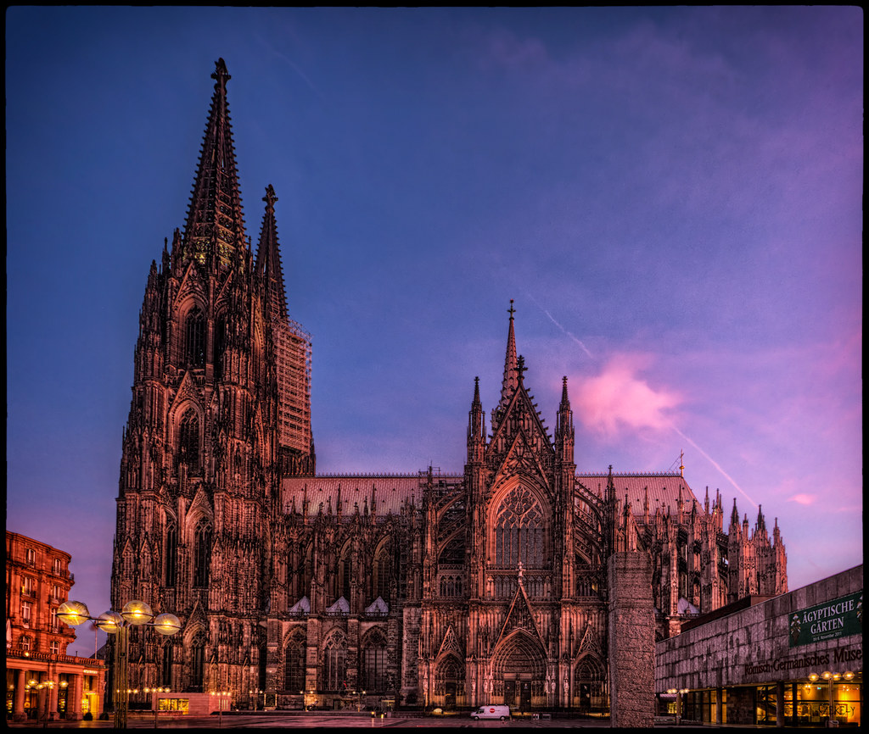

# Cologne Cathedral

**Cologne Cathedral** (German: *Hohe Domkirche St. Petrus* or commonly *Kölner Dom*) is a [Roman Catholic](https://simple.wikipedia.org/wiki/Catholic_Church) [cathedral](https://simple.wikipedia.org/wiki/Cathedral) in [Cologne](https://simple.wikipedia.org/wiki/Cologne), [Germany](https://simple.wikipedia.org/wiki/Germany). It is the cathedral church for the Roman Catholic Archdiocese of Cologne.

The cathedral has a height of 157.25 metres. This makes it the second-highest in Germany and the third-highest in the world. The cathedral in [Ulm](https://simple.wikipedia.org/wiki/Ulm), the [Ulm Minster](https://simple.wikipedia.org/wiki/Ulm_Minster) at 161 metres is the highest in the world. The [Basilica of Our Lady of Peace of Yamoussoukro](https://simple.wikipedia.org/w/index.php?title=Basilica_of_Our_Lady_of_Peace_of_Yamoussoukro&action=edit&redlink=1) is also higher, at 158 metres, but it only has the status of a minor [basilica](https://simple.wikipedia.org/wiki/Basilica), it is not a cathedral. The cathedral is also the third-biggest church, built in [Gothic architecture](https://simple.wikipedia.org/wiki/Gothic_architecture). The [Seville Cathedral](https://simple.wikipedia.org/wiki/Seville_Cathedral) in [Seville](https://simple.wikipedia.org/wiki/Seville), [Spain](https://simple.wikipedia.org/wiki/Spain), and the [Milan Cathedral](https://simple.wikipedia.org/wiki/Milan_Cathedral) in [Milan](https://simple.wikipedia.org/wiki/Milan), [Italy](https://simple.wikipedia.org/wiki/Italy) are bigger.

The Cologne Cathedral was built in [Gothic style](https://simple.wikipedia.org/wiki/Gothic_architecture) from [15 August](https://simple.wikipedia.org/wiki/15_August) [1248](https://simple.wikipedia.org/wiki/1248). It was planned to make the cathedral like the one in [Amiens](https://simple.wikipedia.org/wiki/Amiens_Cathedral). The [choir](https://simple.wikipedia.org/w/index.php?title=Choir_(architecture)&action=edit&redlink=1) was [consecrated](https://simple.wikipedia.org/wiki/Consecration) in 1322. The first bell could be hung in one of the towers shortly after 1410. Around 1510, the construction was stopped, because people had lost interest. The last payment for its construction was made in 1560.

For 300 years, Cologne had an unfinished cathedral. The cathedral was finished in 1880, still following the original plans.

The cathedral became a [UNESCO](https://simple.wikipedia.org/wiki/UNESCO) [World Heritage Site](https://simple.wikipedia.org/wiki/World_Heritage_Site) in 1996.[[1]](https://simple.wikipedia.org/wiki/Cologne_Cathedral#cite_note-wh-1)

The cathedral is one of the most popular sights in Germany. In 2001, there were five million visitors, in 2004, there were six million visitors. [Pope Benedict XVI](https://simple.wikipedia.org/wiki/Pope_Benedict_XVI) visited the cathedral in 2005.